Tanzania Wildlife Discussion Paper No. 37
Rolf D. Baldus (Ed.)

COASTAL FORESTS OF THE
SAADANI NATIONAL PARK

- CONSERVATION VALUES AND MANAGEMENT STRATEGIES -

by

Urs Bloesch and Frank Klötzli




GTZ Wildlife Programme Wildlife Division

in Tanzania Ministry of Natural Resources & Tourism

Dar es Salaam

2004

Contents

Foreword 3
Summary 4
1. Introduction 4
2. Methods 4
3. Description of coastal forest types 5
3.1 Small hilltop forests on hillocks 7
3.2 Gully forests 8
3.3 Forest patches and thicket clumps 9
3.4 Groundwater forests 10
3.5 Gallery forests 12
3.6 Large hilltop forests 13
3.7 Large isolated trees 14
4. Discussion 15
4.1Characteristics of coastal forests 15
4.2 Vegetation dynamics of wooded vegetation 16
4.3 Floral affinities amongst forest types 19
5. Harvesting of forest products 19
5.1 Firewood 19
5.2 Timber and building poles 21
5.3 Non-woody forest products 22
5.4 The Chapa Mangrove Forest 22
6. Conservation values and management suggestions 23
7. Conclusions 25
8. Recommendations 26
9. Acknowledgements 26
10. References 27
11. List of Tanzania Wildlife Discussion Papers Nos. 1 - 40 30

GTZ Wildlife Programme in Tanzania
P.O. Box 1519
Dar es Salaam, Tanzania
www.wildlife-programme.gtz.de/wildlife

The Discussion Papers reflect the opinions of authors only. They may contain views that do not necessarily correspond with the official positions of the Wildlife Division, GTZ and the editor.

Foreword

The major biodiversity and conservation value of Saadani National Park lies not in its mammal populations but essentially in its vegetation, of which the coastal forests are the most conspicuous. These coastal forests are under serious threat and are quickly disappearing along the coast of Tanzania.

German Development Cooperation has assisted the creation of the National Park through the Saadani Conservation and Development Programme. This support was essentially in relation to planning, practical management, capacity building and involvement of the communities in the buffer zones. Some ecological monitoring and collection of basic data was also introduced and certain activities, such as a bird inventory are ongoing. The authors of this Discussion Paper and the Zurich ETH University have a long affiliation with the Saadani-Mkwaja Ecosystem. This paper, similar to a preceding one by them (Bloesch and Klotzli, 2003) serves as a presentation of baseline data. This study also serves the purpose to make this knowledge, accumulated over more than two decades, available to the new managers of Tanzania's latest national park, both now and in the years to come.

It was a particular fortune that the attention of the two researchers was drawn to the hitherto unexplored Kwamsisi coastal forest, which without doubt will offer a few surprises once it can be thoroughly surveyed by scientists. The forests described in this paper cannot, however be conserved in the long run without the active involvement of the communities around the National Park, and the communities need to see clear material benefits. The present trend to develop tourism around Saadani by investors acquiring land from the communities and thereafter excluding them from user rights on the land, the forests and the wildlife on it are cause for major concern.

For a number of reasons Wildlife Management Areas (WMA) around Saadani National Park have not yet been established during the course of the Saadani Conservation and Development Programme. It is however promising that several villages, even in the Genda Genda area have proposed development of WMA, which TANAPA, the Wildlife Division and GTZ have agreed to support. To ensure a smooth development of these WMA, the villages must benefit from tourism development, even that which has started. The present trend that investors purchase agricultural land and build a lodge not only violates existing legislation, but also excludes the villages from long-term tourism benefits. If WMA are established they will require such tourist lodges to pay a rent or bed levy to the WMA even for land that was acquired privately prior to the establishment of the WMA.

The WMA will facilitate the conservation measures and the traditional uses of trees and other forest products as described in this study.

Summary

Twenty-four small coastal forests within the Saadani National Park have been surveyed. According to their topographic position different types have been defined, i.e., small hilltop forest on hillock, gully forest, forest patch/thicket clump, groundwater forest, gallery forest and large hilltop forest. Their floristic composition is analysed and their conservation value is outlined. The dynamics of the wooded vegetation and their main determinants are described. Furthermore, the firewood collection practices of the local communities and its impact on the vegetation are briefly assessed. Based on the findings several management strategies are suggested.

1. Introduction

The main terrestrial vegetation types of the Saadani ecosystem and their biodiversity and conservation values are outlined by Bloesch & Klötzli (2002). They stress in particular the high biodiversity and the exceptional endemism of the poorly known coastal forests within the Saadani savanna landscape. Moreover, they underline the importance of effective community participation and the appropriate use of fire in view of a sustainable management of the area.

In this report we discuss the main findings of a field survey carried out from 27/7 – 8/8/2003 in order to complement our knowledge of the coastal forests. In particular the following aspects are discussed:

- Botanical description of the different forest types and assessment of their biodiversity values;
- Establishment of the floristic affinities between the analysed different forest types;
- Tentative description of the dynamics of the different forest types;
- Description of the conservation values of the wooded vegetation and of their main threats;
- Rapid assessment of the firewood collection practices of the local communities and its impact on the vegetation;
- Suggestions for management strategies regarding these forests.

A more exhaustive floristic analysis and a list of all species recorded (indicating endemic species) will be published in a scientific journal. This paper will also compare our forest data with that of other coastal forests known from the literature, particularly the Zaraninge Forest.

2. Methods

For the biogeographical description of the study area we refer to Bloesch & Klötzli (2002). To get a representative overview of the diversity of the coastal forests within the Saadani National Park, 24 individual forests1 (woodlands) were surveyed. As selection criteria we considered their topographical position, physiognomy as well as their location (representative distribution). The selection process was facilitated by the field knowledge of the Park authorities, the preliminary vegetation map based on satellite images and aerial photographs from R. Cochard and M. Tobler and also our own knowledge of the area. We visited the Zaraninge Forest only briefly and did not conduct any detailed studies for time reasons and since Frontier-Tanzania / WWF (Mwasumbi et al. 1994, Clarke & Dickinson 1995) had already carried out extended surveys.

One plot (relevé) with co-ordinates recorded by a Garmin 12 XL GPS (Global Positioning Systems) was surveyed in a representative part of each forest following the method of Braun-Blanquet (1932). Within a given plot the cover-abundance value of all species (nomenclature according to Beentje 1994) was recorded, separately for the tree/shrub- (25 x 25m) and the herbaceous layer (5 x 5m). The following scale was used:

5: Any number, with cover more than 75% of the reference area
4: Any number, with cover 50-75%
3: Any number, with cover 25-50%
2: Any number, with cover 5-25%
1: Numerous, but less than 5% cover, or scattered, with cover up to 5%
+: Few, with small cover

The relevés were grouped into different forest types according to their topographic position. The dominant (cover-abundance value of at least 2 in one stand), and the common woody species (constancy of at least 60%), are given for each forest types (having at least four relevés). Floristic affinities between the different forest types were identified. Moreover, the species richness is expressed using the alpha-diversity, i.e., the average total species number per plot for each forest type.

Brief inquiries were conducted in form of informal interviews with some community members of Saadani, Matipwili and Mbuyuni Kitopene villages about their firewood collecting practices and the preferred species for timber and building poles.

3. Description of coastal forest types

The Saadani ecosystem is an old one (see Hawthorne 1993; Clarke & Karoma 2000) having a rich vegetation mosaic composed of various terrestrial and aquatic ecosystems (Bloesch & Klötzli 2002). The coastal forests are a characteristic feature of this savanna landscape consisting of highly heterogeneous and diverse assemblages of forest types (Fig. 1, see Clarke & Robertson 2000; Clarke et al. 2000), which renders any classification very difficult. Hawthorne (1993) distinguished between moist and dry coastal forests and further used for a finer classification the eco-geographical and chorological elements. Clarke & Robertson (2000) recognise five major types of coastal forests within the eastern African coastal zone:

- Coastal dry forests including legume-dominated dry forests and mixed dry forest
- Coastal scrub including mixed scrub forest and maritime scrub forest
- Coastal Brachystegia forest
- Coastal/afromontane transitional forest
- Coastal riverine-, swamp- and groundwater forest

According to their topographical position we define 6 types of coastal forests along a typical catena, from hilltop to valley floor, and we find the following recurrent elements of the savanna landscape (see also Fig. 8):

- Small hilltop forests on hillocks (relevés N° 2, 5, 7, 10, 18, 22);
- Gully forests on variable topographical position (relevés N° 12, 19);
- Forest patches / Thicket clumps on variable slope (relevés N° 3, 4, 11, 15, 17);
- Gallery forests (8, 16, 21);
- Groundwater forests (relevés N° 9, 13, 20, 23); relevé 14 (Borassus aethiopum stand) not considered for the analysis since it is incomplete;
- Large hilltop forests occurring on higher elevation at Zaraninge and Kwamsisi (relevé N° 24);

In addition, two almost monospecific (savanna) woodlands2 were surveyed which will be not further analysed in this report:

- Acacia robusta ssp. usambarensis In valley bottoms (relevés N° 6);
- Pteleopsis myrtifolia on moderate slope (relevés N° 1).

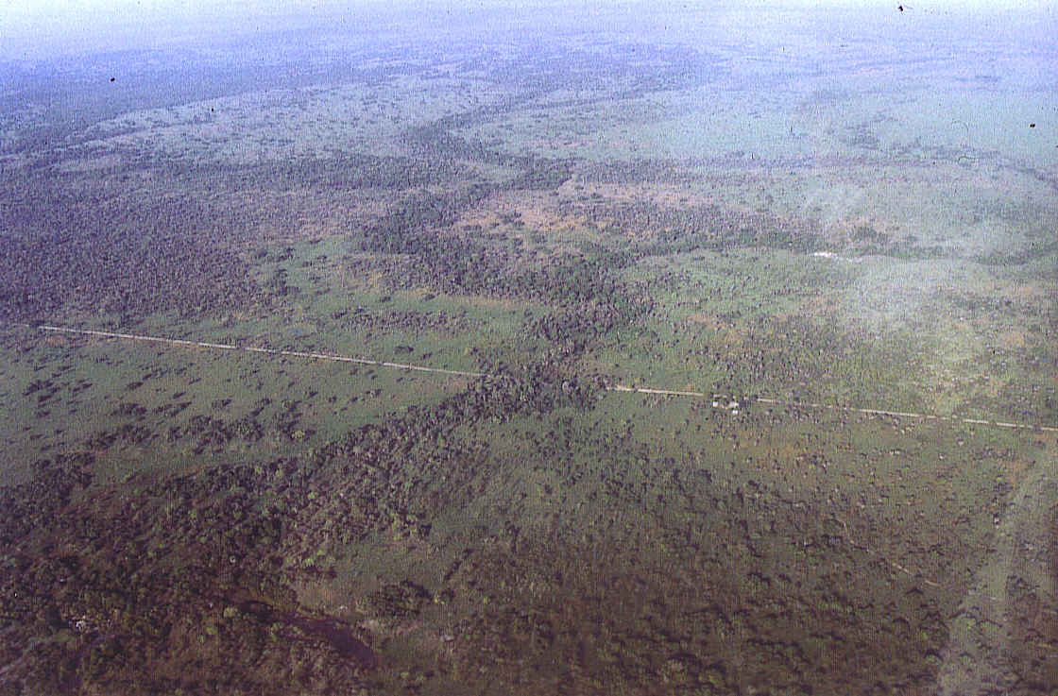

Fig. 1. The Saadani forest-savanna mosaic

Due to disturbances, in particular by humans and elephants, parts of some forests could be considered as scrub forest (White 1983), but since their extent is small and regeneration is quite rapidly (if there are no further disturbances), we prefer to conceive them as forests. Our vegetation communities like those of Hawthorne (1993) and Clarke & Robertson (2000) are descriptive and have not been defined statistically lacking sufficient data. The relevés of the 24 different coastal forests will be published in a scientific journal.

3.1 Small hilltop forests on hillocks

Hillocks are a common feature of the Saadani National Park. Usually their top and the upper part of the slopes are covered with low forests composed of mostly gnarled trees. This forest type usually extends over 1 to 5 ha often having gaps due to elephants. Hilltop forests have the driest substrate of all coastal forests. Almost each small hilltop forest has its own dominant species as shown in Table 1 below.

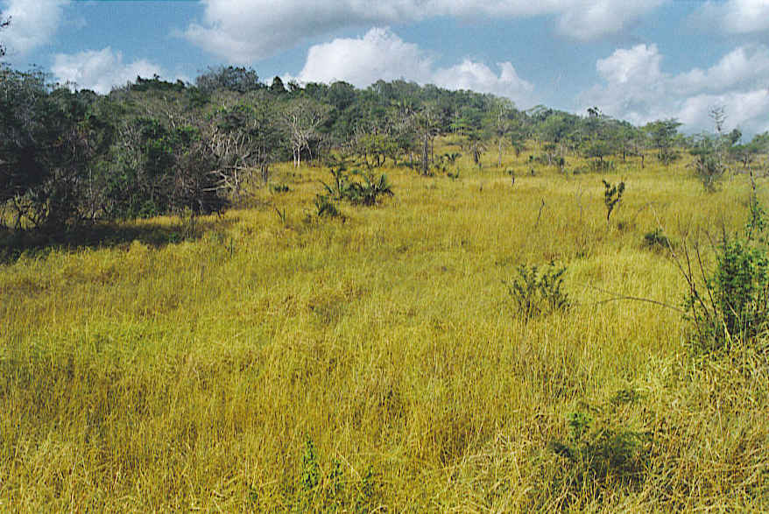

Fig. 2. Small hilltop forest at Mkwaja North

Table 1. Vegetation characteristics

Aspect | Tree layer | Shrub layer | Herb layer
Stand structure  Height  Cover | 8 – 16 (25) m  30 – 60 % | 0.3 – 3 m  10 –35 % | 0 – 0.3 m  <1 – 10 %
Alpha-diversity |  | 29 species
Dominant species | Albizia anthelmintica  Albizia petersiana  Apodytes dimidiata  Diospyros consolatae  Diospyros cornii  Diospyros kirkii  Drypetes reticulata  Haplocoelum foliolosum  Julbernardia magnistipulata  Manilkara mochisia  Manilkara sulcata  Margaritaria discoidea  Monanthotaxis buchananii  Pteleopsis myrtifolia  Rapanea sp.  Rhoicissus revoilii  Salvadora persica  Tamarindus indica | Aïdia micrantha  Canthium mombazense  Combretum holstii  Drypetes reticulata  Haplocoelum inoploeum  Hypoestes forskalei  Gutenbergia sp.  Julbernardia magnistipulata  Monanthotaxis buchananii  Polysphaeria parvifolia  Suregada zanzibarensis  Trilepisium madagascariens. | Oplismenus compositus
Common species | Aïdia micrantha, Canthium mombazense, Manilkara sulcata

3.2 Gully forests

Gully forests are usually found in the Saadani National Park as narrow belts along seasonal drainage courses on moderate slopes on undulating or dissected topography. The forest canopy encloses entirely the seasonal drainage course (usually less than 3 meters wide). These small gullies are moister than surrounding slopes and ridge tops, since the collection of both surface and groundwater provides an additional moisture supply. In some cases, the gully forests expand over several gullies at their upper most part but their overall size does not exceed a few hectares. The canopy is continuous like that of the gallery forests along seasonal water courses which leads to a very sparse herb layer. The species composition of gully forests barely differs from forest patches. Following floristic criteria, it seems that the distinction of gully forest as own forest type is not justified.

Table 2. Vegetation characteristics

Aspect | Tree layer | Shrub layer | Herb layer
Stand structure  Height  Cover | 12 – 16 (20) m  30 – 50 % | 0.3 – 3 m  25 – 30 % | 0 – 0.3 m  <1 %
Alpha-diversity |  | 24 species
Dominant species | Deinbollia borbonica  Diospyros cornii  Manilkara mochisia  Manilkara sulcata  Ochna holtii | Asteranthe asterias  Canthium mombazense  Carissa tetramera  Hunteria zeylanica  Manilkara mochisis  Uvariodendron kirkii

3.3 Forest patches and thicket clumps

In this study only larger forest formations, i.e. forest patches have been surveyed. This forest type of very variable size occurs on different slopes having a highly heterogeneous stand structure. Hilltop forests and forest patches have relatively few dominant species in common but nevertheless many species like e.g., Aïdia micrantha, Diospyros consolatae, Manilkara mochisia, M. sulcata or Strychnos panganensis occur in both communities. The endemic palm fern Encephalartos hildebrandtii is a characteristic plant of forest patches (also occurring in one hilltop forest).

Table 3. Vegetation characteristics

Aspect | Tree layer | Shrub layer | Herb layer
Stand structure  Height  Cover | 8 – 15 (25) m  25 – 45 % | 0.3 – 3 m  5 –65 % | 0 – 0.3 m  <1 – 35 %
Alpha-diversity |  | 30 species
Dominant species | Baphia kirkii  Cleistanthus schlechteri  Commiphora pteleifolia  Deinbollia borbonica  Diospyros consolatae  Drypetes reticulata  Haplocoelum foliolosum  Manilkara mochisia  Mimusops somaliensis  Salvadora persica  Scorodophloeus fischeri  Xylopia aethiopica | Asteranthe asterias  Canthium mombazense  Carissa tetramera  Croton pseudopulchellus  Diospyros consolatae  Hunteria zeylanica  Manilkara mochisia  Maytenus undata  Polysphaeria parvifolia  Scorodophloeus fischeri  Strychnos panganensis  Suregada zanzibarensis  Teclea simplicifolia  Uvariodendron kirkii | Canthium mombazense  Oplismenus compositus  Scorodophloeus fischeri
Common species | Hunteria zeylanica, Manilkara sulcata, Strychnos panganensis, Uvariodendron kirkii

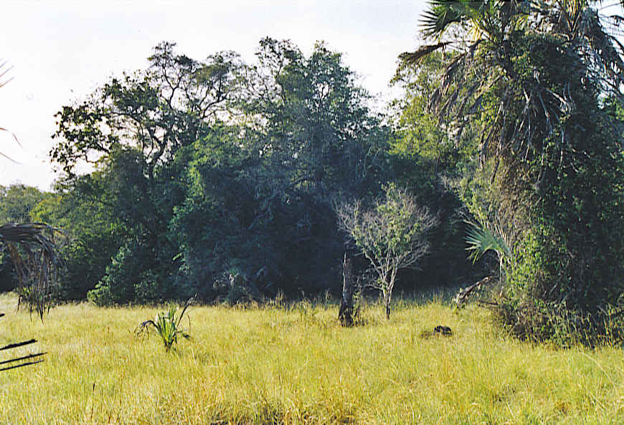

Fig. 3. Forest patch at Mkwaja North

3.4 Groundwater forests

Groundwater forests may occur on permeable sandy silt valley bottoms with a high groundwater table. On sandy, well-drained soils almost monospecific stands of the African fan palm (Borassus aethiopum) are frequent. Groundwater forests and gallery forests are in practice difficult to separate, since areas of gallery forests are effectively groundwater forests not having direct contact with river water. Consequently many of their species are common, as e.g. Sorindeia madagascariensis which we found only in these two plant communities. Groundwater forests have the highest biodiversity of all forest types with 35 species per relevé in average.

Table 4. Vegetation characteristics

Aspect | Tree layer | Shrub layer | Herb layer
Stand structure  Height  Cover | 10 – 16 (25) m  40 – 75 % | 0.3 – 3 m  10 –30 % | 0 – 0.3 m  <1 – 40 %
Alpha-diversity |  | 35 species
Dominant species | Celtis philippensis  Cleistanthus schlechteri  Diospyros consolatae  Hymenaea verrucosa  Julbernardia magnistipulata  Manilkara sulcata  Sorindeia madagascariensis  Strychnos panganensis  Tamarindus indica | Aïdia micrantha  Canthium mombazense  Combretum holstii  Diospyros kirkii  Erythroxylum fischeri  Euclea natalensis  Haplocoelum foliolosum  Nesogordonia holtzii  Ochna holtzii  Sorindeia madagascariensis  Syzygium sp.  Teclea simplicifolia | Achiranthes aspera  Combretum holstii  Crossandra pungens  Ochna holtzii  Oplismenus compositus
Common species | Aïdia micrantha, Polysphaeria parvifolia, Haplocoelum foliolosum

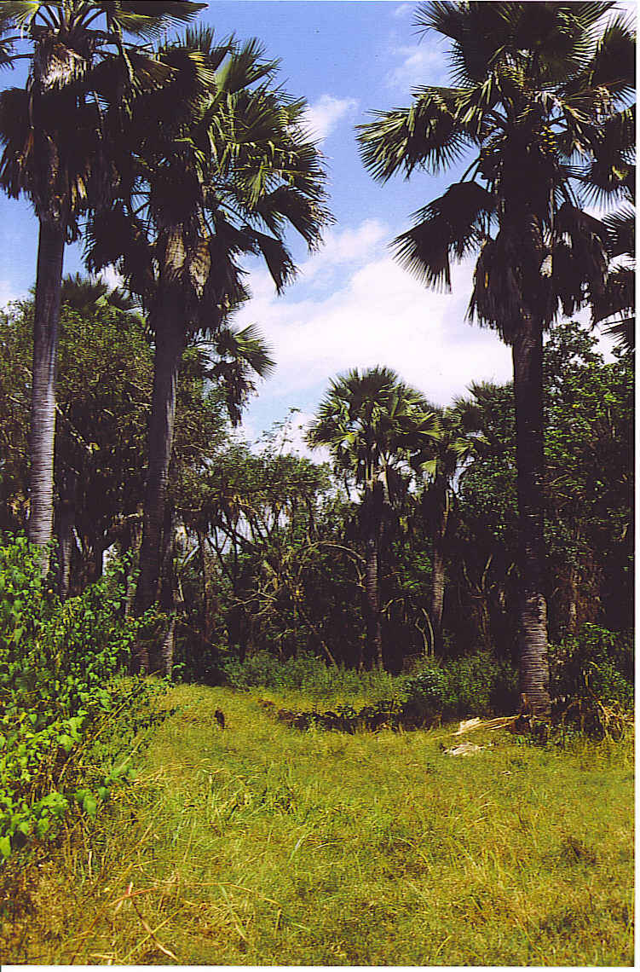

Fig. 4. Borassus stand along the Sima River

3.5 Gallery forests

Gallery forests are found along watercourses in flat areas. Except for the Wami River, which flows along the southern border of the Park, and at the source in the Kwamsisi Forest all other watercourses are seasonal. Similar to gully forests, usually a narrow band of trees and shrubs (about 10 to 20 metres wide) encloses entirely the seasonal watercourse leading to a better water supply (see gully forests). Relevés were taken at Msangazi (N° 8), Sima (16) and Kombe River (21). The plots were strictly located on the river talus only to avoid recording plants from the ecotone of the surrounding savannas on flat area.

The structure and the floristic composition of these narrow forests are highly variable depending on the characteristics of the riverbed and its talus. The talus is usually between 2 and 5 (8) m high having mostly a steep slope angle of up to more than 100%. The stand height is about 20 m with a low tree canopy density. Exceptionally, some tree specimen may reach a height of up to 25 m. Locally, the shrub layer may be very dense. Each gallery forest has its specific species composition. The dominant woody species Acridocarpus zanzibaricus, Antidesma venosum, Cynometra suahelensis, Garcinia buchananii and Ficus sycomorus, occur only in this type of forest. Further characteristic woody species are Baphia kirkii and Polysphaeria braunii. Only few seedlings (e.g. Strychnos henningsii), which germinated after the last rainy season occasionally root in the riverbed.

Table 5. Vegetation characteristics

Aspect | Tree layer | Shrub layer | Herb layer
Stand structure  Height  Cover | 10 – 16 (25) m  40 – 75 % | 0.3 – 3 m  10 –30 % | 0 – 0.3 m  <1 – 40 %
Alpha-diversity |  | 35 species
Dominant species | Acacia robusta ssp. usambar.  Antidesma venosum  Baphia kirkii  Cynometra suahelensis  Ficus sycomorus  Garcinia buchananii  Manilkara sansibarensis  Sorindeia madagascariensis  Strychnos panganensis  Stuhlmannia moavi | Acridocarpus zanzibaricus  Baphia kirkii  Hunteria zeylanica  Ochna holtzii  Polysphaeria braunii  Polysphaeria multiflora  Stuhlmannia moavi | Panicum trichocladum

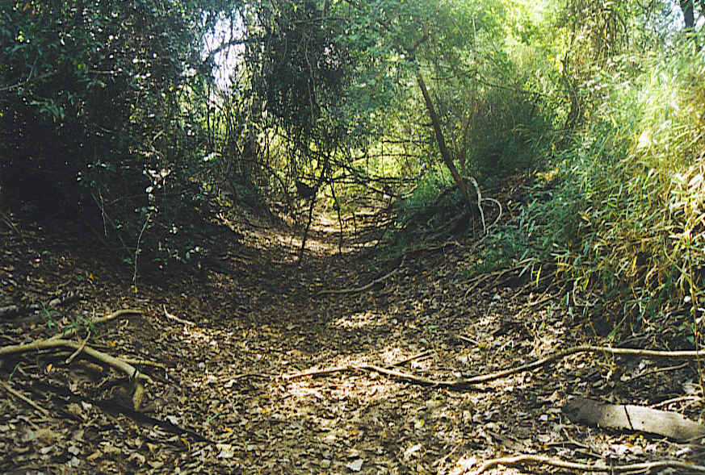

Fig. 5. Msangazi gallery forest (Mkwaja North)

3.6 Large hilltop forests

This type of forest occurs at higher elevations (often on plateaux) than the other forest types. As outlined, no detailed vegetation survey has been carried out in the Zaraninge Forest. Thanks to the personal knowledge of the Park Warden we discovered (just on our last day of the fieldwork) about 10 km south of Kwamsisi village an unknown large coastal forest of several square kilometres which was not yet surveyed. The forest stretches over several hills, between about 100 and 200 m a.s.l. The site conditions of this forest are highly heterogeneous due to the very variable relief.

Due to its more westward location the area has most probably a higher annual rainfall than areas closer to the sea (see Bloesch & Klötzli 2002). Only the smaller part of this forest around a permanent water source is proposed to be included in the National Park (Kwamsisi extension). The source would fulfil an important function as water supply for animals during the dry season. The Park Authorities are planing to construct a game post just uphill of the source. The larger part of the Kwamsisi Coastal Forest is on open land.

We were able to survey only one vegetation plot (relevé N° 24) during our mission due to time constraints. The biodiversity is relatively low with 23 species. The dominant species of the tree layer are Haplocoeulum foliolosum and Stuhlmannia moavi while Cola microcarpa, Combretum sp. and Diospyros consolatae dominate the understorey. Characteristic are further many succulent plants like Aloe sp. or Sansevieria sp. and the endemic Zamiaculcas zamiifolia (Araceae).

Kwamsisi has also a certain potential for eco-tourism due to the scenic value of the dissected landscape. The higher elevation of Kwamsisi offers a nice view on the savanna landscape which stretches towards the Indian Ocean.

According to Sheil (1992) coastal forests on raised ground like those from Zaraninge and Kwamsisi were not flooded during Pleistocene sea-level changes (see also Clarke & Burgess 2000) and may have existed since the late Cretaceous. It is therefore believed that these ancient forests have a high proportion of single site endemics. A thorough survey of the entire Kwamsisi Forest will most likely show that this forest has a high conservation value equal to the relatively well-known Zaraninge Forest.

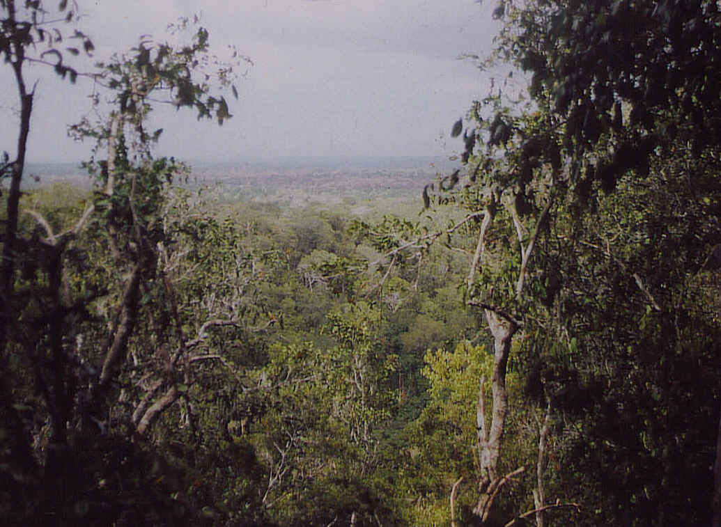

Fig. 6. Kwamsisi Forest

3.7 Large isolated trees

Some large conspicuous isolated trees are a further feature of the Saadani ecosystem. For instance, the grotesquely voluminous baobab (Adansonia digitata) northwest of Mbuyuni village, gnarled huge oak-like Mimusops somaliensis or Tamarindus indica dominating a thicket clump or pale yellow erect boles of Sterculia appendiculata trees, emerging above the surrounding vegetation highly contribute to the attractiveness of the savanna landscape.

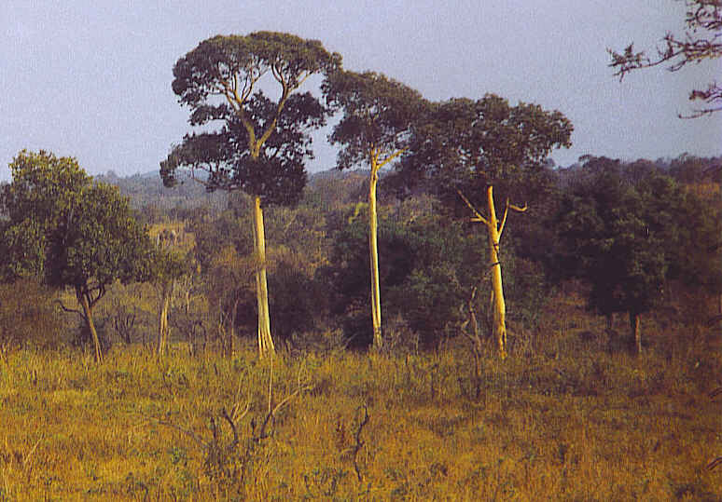

Fig. 7. Sterculia appendiculata near Mkalamu

4. Discussion

4.1Characteristics of coastal forests

Coastal forests in the Saadani ecosystem are highly variable in size, shape and structure. There is no distinct stratification below the canopy. Coastal forests are classified as dry evergreen forests because the great majority of the woody plants are evergreen3 and they have to endure a distinct dry season. The periodical dryness of these sites is further enhanced by the high sand content of the substrate. Savannas to the contrary, have mainly deciduous4 woody plants.

The species richness of our studied forests varies between 23 (Kwamsisi) and 35 species (Groundwater forest). Understorey species are more diverse than canopy species. Especially in thinner parts of the forest there is a rich community of smaller trees (5 – 8 m), shrubs (1 – 5 m) and lianas. The margins are mainly composed of often scandent armed shrubs and of lianas which are thickly interlaced what almost impedes any penetration. The herbaceous layer is sparse and only abundant in gaps.

Each forest has its own specific species composition although ubiquitous species are frequent. The woody plants Aïdia micrantha, Combretum mombazense and Manilkara sulcata occur in all forest types. Species of the plant families Caesalpiniaceae, Papilionaceae, Sapindaceae, Sapotaceae and Rubiaceae are the major components of the canopy of coastal forests. Some of them like Deinbollia borbonica, Manilkara sulcata or Julbernardia magnistipulata frequently form almost monospecific stands (see also Hawthorne 1993). Legume-dominated coastal forests may be considered as climax, since their shrub layer is often dominated by the same species as the tree canopy as shown in the relevés 17 and 18 (see also Clarke & Robertson 2000).

Most coastal forests in the Saadani National Park are mixed dry forests according to Clarke & Robertson (2000). Many of their species such as Drypetes natalensis, Lecaniodiscus fraxinifolius, Haplocoelum foliolosum, Manilkara mochisia, Milicia excelsa or Pteleopsis myrtifolia are geographically widespread with a wide ecological amplitude. The seeds of most of these species are wind or animal dispersed thereby having competitive regeneration advantage over the more slowly dispersed legume seeds (especially Caesalpinioideae, see Clarke & Robertson 2000).

Common to all coastal forests is a high proportion of evergreen woody plants and a sharp ecotone with the surrounding savanna. In contrast, woodlands have large continua with their adjacent savannas. Coastal forests have a distinct floristic composition. They only share a few common woody plants with their surrounding woodlands and savannas (excluding juvenile thicket clumps and the ecotone domain) such as Adansonia digitata, Afzelia quanzensis, Pteleopsis myrtifolia or Synaptolepis kirkii.

Our initial classification of forest types is not confirmed by our preliminary analysis of their floristic species composition. Only gallery forests show a distinct species composition. Additional relevés are necessary to refine our initial classification of small coastal forests based on topographical criteria.

4.2 Vegetation dynamics of wooded vegetation

The dynamics of savanna landscapes are not uniform and vary considerably in space and time. Generally, climate, soils, herbivory, fire and also termites (see Bloesch 2002) are considered as main determinants of the tree-grass ratio. Most main determinants not only determine the dynamics by constant impact of similar importance but often act as abrupt, short-lasting disturbances like e.g. extreme rainfall or changes in the fire regime or changes in the patterns of human use (such as cattle grazing or agriculture). Disturbances are strongly interactive, they may have direct (e.g. logging) and indirect effects (e.g. browsing by elephants may open the canopy thereby promoting grass growth which leads to an increased fire hazard) on the vegetation physiognomy. They also influence the response of the ecosystem to future disturbances.

In the Saadani savanna landscape, soil properties play a major role for the occurrence and dynamics of coastal forests (see Fig. 8). The highly permeable sandy soils and the sporadic rocky outcrops on hilltops (favours deep rooting woody plants and provides a certain fire protection), the better water supply along seasonal water courses (including gullies) and the high water table in well-drained valley bottoms favour woody plants at the expense of grasses. This mainly explains the distribution pattern of hilltop, gully, groundwater and gallery forests. Fire, the current herbivory (in particular elephants) and in part timber logging and cutting of poles modulate primarily the physiognomy of the forest but only slightly influence their extent.

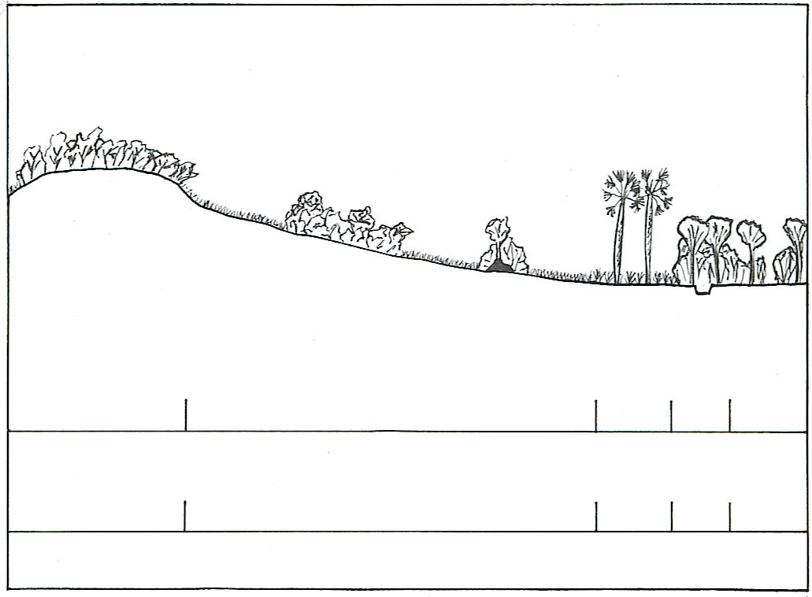
HF
TSGS
GWF
GF
GWF
Main determinants

Soil type
Soil
Fire, Herbivory Termitaria, Soil
Soil
Soil
Soil
Humic, acric to
rhodic Ferralsol
Orthic and ferric Acrisol
dystric
Planosol
dystric
Planosol
Gleysol,
Fluvisol
Current dynamics of some forest types within the Saadani National Park

Fig. 8. The occurrence and dynamics of hilltop, gully (not shown), groundwater and gallery forests are widely a function of the soil properties favouring tree growth at the expense of grasses and herbs. Forest patches and thicket clumps on slopes (exceptionally on flat areas), which are irregularly distributed within a savanna matrix, however, are determined by several interactive factors, i.e. fire, herbivory, termitaria and soil (details see text).

HF: hilltop forest TSGS: tree to grass savannas with interspersed forest patches and thicket clumps
GWF: groundwater forest GF: Gallery forest

On the other hand, the occurrence and dynamics of forest patches and thicket clumps (not surveyed during this mission) on slopes and flat areas (permeable soil and without access to ground water) are not directly a function of the soil properties but rather the result of a varying combination of factors: fire regime, herbivory, termitaria and soil properties.

The genesis of thicket clumps may start with a heliophilous tree like Zanthoxylum chalybeum often associated with a temporarily abandoned termitaria. Macrotermitinae mounds may initiate and support the growth of thicket clumps in three ways (see Bloesch 2002):

- Fire protection as a result of the slight elevation above the grass fires and often bare soil at the foot-slope of the mound
- Increased soil fertility in many cases.
- Good soil drainage in seasonally flooded flat areas.

The stem and crown of the pioneer tree offers support to progressively invading climbers playing an important role in the development of thicket clumps. Juvenile thicket clumps are often composed of the shrubs (trees) Albizia petersiana, Crossopteryx febrifuga, Diospyros zombensis, Euclea natalensis, Flacourtia indica, Flueggea virosa, Harrisonia abyssinica, Lannea schweinfurthii, Maerua triphylla, Ochna mossambicensis, Polysphaeria parvifolia, Uvaria kirkii and the more scandent shrubs Bridelia cathartica, Combretum constrictum, Grewia holstii, G. sulcata, and G. bicolor. Most of these pioneer trees and shrubs are typical savanna woody plants.

The increasing shading in the thicket clump leads to lesser grass growth, thereby reducing the grass competition, which may favour the germination of numerous sciaphilous plants, typical for coastal forests. They replace gradually the pioneer trees and shrubs. Usually one sciaphilous tree (often Diospyros sp., Manilkara sp. or Tamarindus indica) acts as nucleus for the growing thicket clump. The installation of more species in the periphery of thicket clumps may lead to a centrifugal growing process thereby forming the often hemispheric form of thicket clumps. The extension and regress of thicket clumps are predominately determined by the fire regime, the grazing intensity in the surrounding savannas and the browsing intensity (mainly elephants) within thicket clumps (in seasonally flooded areas woody plants can not grow beyond the termitarium).

Coastal forest are mainly composed of pyrophobic species contrary to the fire-tolerant savanna woody plants (see Bloesch 2002). Savanna fires usually only scorch their edge and do not penetrate intact coastal forests. The low flammability of coastal forests may have the following reasons (see also Bloesch 2002):

- The scarce herbaceous layer and the presence of some almost not flammable succulents like Aloe spp., Euphorbia nyikae and E. tirucalli, Kalanchoe spp., Sansevieria spp., and Sarcostemma spp. prevents any ground fire.
- The high proportion of evergreen species having in general a low flammability and producing less litter for ground fires than do deciduous woody plants that often have synchronised leaf fall during the dry season.
- The dense curtain at the forest edge composed mainly of scandent shrubs and lianas (e.g. Ampelocissus spp. and Cissus spp.) of mostly low flammability hinders the penetration of savanna fires.

In the absence of human (cutting) and elephant disturbances along the forest edge recurrent fires enhance the sharpness of the ecotone between forests and savannas.

If there is no fire (or only of low intensity), low browsing and low cutting impact the thicket clumps may expand to larger forest patches. We estimate, that under favourable conditions the forest-savanna boundary line may progress at maximum 20 – 30 cm per year (see also Bloesch 2002). On the other hand, mainly intense browsing by elephants (and/or intense wood exploitation) may reverse the process, in particular if the impact occurs along the forest edge. Elephants may reduce the tree/shrub cover by a) breaking off large branches or even knocking down, respectively, uprooting trees and shrubs, b) ring barking, and/or c) trampling the understorey woody plants. As a result, light penetration may increase sufficiently to permit the spread of grasses into the forest thereby producing enough easy flammable fuel to carry fire from the surrounding savannas into the forests. Once forests are converted, savannas are easily maintained since tree seedlings are not able to regenerate themselves under regular burning. On the other hand, gaps within forests created by elephants are usually rapidly closed by abundant natural regeneration and lateral growth of neighbouring trees and shrubs, provided that the openings are surrounded with dense forest thereby preventing the entering of savanna fires. Under the current fire regime (sporadic fires of mostly low intensity) and the relatively low browsing impact by elephants, forest patches and thicket clumps tend to expand.

Our findings confirm that there is little evidence to assume that forests grew throughout the Tanzanian coast in the Late Pleistocene and early Holocene (see also Bloesch & Klötzli 2002), although their extend became greatly reduced (see 6. Conservation values and management suggestions).

4.3 Floral affinities amongst forest types

The highly heterogeneous determinants, i.e., climate, geology, geomorphology, soils (see Hawthorne 1993) and site specific disturbances (mainly by humans) create the very complex mosaic of vegetation types throughout the coastal forest belt. Each single forest has its own dynamics leading to a site-specific vegetation structure: At least 484 tree species have been recorded in the literature to be locally dominant or common in at least one coastal forest in eastern Africa (see Burgess & Clarke 2000, appendix 2). The similarity between and within forest types is therefore low. The floristic affinities of coastal forests will be further analysed in the foreseen scientific publication.

5. Harvesting of forest products

According to the terms of reference our task was limited to a brief assessment of the firewood collection practices. Nevertheless, we also make some general comments about cutting of timber and poles and the collection of non-woody forest products.

5.1 Firewood

The preferred firewood species in Saadani, Matipwili and Mbuyuni Kitopene villages are listed below in Table 1. Since our survey was very brief and mainly based on the interviews with few people the results have to be interpreted carefully. Also, for some firewood species we got only their Swahili name without confirming it with a plant sample.

Table 1. Preferred fire wood species

Species | Saadani  (24 species) | Matipwili  (8 species) | Mbuyuni Kitopene  (14 species)
Mbanga chuma / Olax obtusifolia  Mchaaka / Spirostachys africana  Mchala / Albizia petersiana  Mda / Diospyros zombensis  Mdaa wa bara / Euclea racemosa ssp. schimperi  Mdaa wa pwani / Avicennia marina  Mfyonzi / Lamprothamnus zanguebaricus  Mgombegombe / Sideroxylon inerme  Mhale / Strychnos sp.  Mkandaa? / Bruguiera gymnorrhiza  Mhande  Mkanga  Mkanju / Anacardium occidentale  Mkarata / Acacia hockii  Mkole / Grewia bicolor  Mkomafi (Mtonga) / Xylocarpus granatum  Mkongolo  Mkongowe  Mkoko / Rhizophora mucronata  Mkora / Grewia conocarpa  Mkulajembe / Dichrostachys cinerea  Mkunguni? / Maytenus undata  Mmgo  Mmumbu? / Lannea schweinfurthii  Mnazi / Cocos nucifera  Mn’gambu / Manilkara mochisia  Mliwaliwa  Mngongo / Sclerocarya birrea  Mpawe / Haplocoelum inoploeum  Msurugura / Olea europaea ssp. africana  Mtakawa? / Hibiscus tiliaceus  Mtutuma? / Catunaregam nilotica  Mvinje / Casuarina equisetifolia  Mwangaa / Terminalia spinosa  Myombo / different Caesalpinioideae  Mzigunga / Acacia zanzibarica  Nvelendende / Flueggea virosa | X  X  X  X  X  X  X  X  X  X  X  X  X  X  X  X  X  X  X  X  X  X  X  X | X  X  X  X  X  X  X  X | X  X  X  X  X  X  X  X  X  X  X  X  X  X

N.B. Mangrove species in bold

Wood is relatively abundant in the vicinity of the villages at the periphery of the Saadani National Park and women and children only collect dead wood. Due to the abundance and easy accessibility of firewood no firewood market exist in the Saadani area. Altogether 36 firewood species are used in the three localities. Since there is actually enough dead firewood available the wide range of species underlines the high calorific value and the good burning properties of many natural woody plants in the Saadani ecosystem. Species desirable as fuel are those which burn slowly and hot, with little smoke, but it seems that the principal selection criteria are species accessibility and ease of collection (see also Fleuret 1983).

Only five identical species are preferred in two localities and only Acacia zanzibarica and the Red Mangrove Rhizophora mucronata are used in all three localities. Acacia zanzibarica is the dominating species within the Park. Disturbances like overgrazing or cutting may lead to vigorous encroachment by this species. Large areas around the paddocks of the former Mkwaja cattle ranch got heavily encroached (see Walther 2002 and Tobler et al. 2003). People from Sea Salt (about 15 km south of Saadani village) also reported an important spreading of Acacia zanzibarica in the vicinity of the settlement since their arrival in the eighties; this process was probably favoured by cutting. Mangroves are well known as good firewood (and charcoal) species and they are in particular appreciated by people from the Saadani village where coastal mangrove stands are relatively nearby.

The local people from Matipwili further listed the following species suitable for charcoal: Mkongowe (Acacia sp.), Mkwaju (Tamarindus indica), Mtondoro (Calophyllum inophyllum?) and Mngogi (Pteleopsis myrtifolia). Currently no charcoal production is recorded from the area within the National Park (but see 5.4)

The daily firewood consumption is assumed to be about 2 kg per head or about 1 m³ per year (see De Montalembert & Clements 1983 and Bloesch 2001). The only estimate from coastal forests from the East Usambara lowlands is 332 – 572 kg per person and year (Cambridge-Tanzania Rainforest Project 1994) what seems to be too low. It seems that the actual demand of firewood by the local population in the vicinity of the Park can be met by the use of dry wood only.

This new National Park has a high potential for tourist development due to its coastal location offering beach and safari tourism and its vicinity to Dar es Salaam and Tanga. Many investors have already bought land along the beach. The demand for firewood (charcoal) for running the tourist business and for the domestic needs of their employees and their families (probably mostly coming from outside) is likely to increase dramatically in the near future. It is therefore highly necessary to both assess and closely monitor the additional firewood and charcoal demand and the supply pattern (collection areas). Also the need of firewood by salt boilers (see Clarke & Stubblefield 1995) should be assessed. According to the expected increase in firewood consumption the dissemination of energy saving methods (e.g. improved clay stove instead of the traditional 3-stone stove) should be considered.

As far as we observed in the vicinity of Saadani village the local people only collect dead firewood what does not harm the ecosystem. Currently the local people from Saadani and Mbunyuni Kitopene villages also collect firewood in parts of the National Park. Formerly these areas belonged to the Saadani Game Reserve and the local communities had the rights to collect firewood. The abolition of traditional rights may cause serious problems in the collaboration with the local communities but on the other hand, the uncontrolled entering of people in the Park, may render the anti-poaching patrolling very difficult. A possible solution could be the permission of collecting dead firewood within clearly defined perimeters during fixed hours, one (two) day(s) a week.

The permission for gathering dry firewood under certain rules could also contribute to a good collaboration with the local population and could thereby help to initiate a community-based approach in the periphery of the Park in favour of a sustainable use of the natural resources. We are fully aware that actually any form of collaborative management arrangement within the National Parks in Tanzania is not allowed. Nevertheless we believe that the attribution of limited and clearly defined rights (which are controllable) does not jeopardize the conservation of the ecosystems within the Park but it could even improve the relationship between the Park authorities and the local communities.

5.2 Timber and building poles

The relatively easy accessible coastal forests meant that they were one of the earliest sources of timber from East Africa (see Burgess & Mbwana 2000). Along with the development and management of Forest Reserves in Tanzania and Kenya, their most valuable timber species were the heaviest exploited, and many forests have been exhausted of Milicia, Khaya, and Brachylaena. Species of Hymenaea, Baphia, Afzelia and Manilkara, all present in the Saadani National Park, have been more recently exploited, or are increasingly used now since the most appreciated species have become unavailable (see Burgess & Mbwana 2000). Currently, timber logging is not conceived as a major problem by the Park authorities although we discovered fresh cutting of two Julbernardia magnistipulata trees along the Sima River, and timber logging occasionally occurs in the Zaraninge Forest. The demand for building poles (mainly for house construction) is high within rural communities (see Burgess et al. 2000) and it is assumed that cutting of poles does occur in forests at the periphery of the Park.

According to our brief interviews the local population mentioned the following species suitable for timber (Table 2).

Tables 2. Preferred species for timber

Species | Saadani | Matipwili
Mbamba Kofi (Mkomba or Mkongo) / Afzelia quanzensis  Mkomafi / Xylocarpus granatum (Mangrove Mahogany)  Mkula  Mninga  Mtondoro / Calophyllum inophyllum?  Mngongo / Sclerocarya birrea  Mvule / Milicia excelsa | X  X  X  X  X | X  X  X  X  X

5.3 Non-woody forest products

Coastal forests are also an important source of non-woody forest products for the rural communities. Medicinal plants, gum copal5, edible plants and mushrooms, bush-meat and wild honey play a considerable role for the subsistence mainly for poor households (see Burgess et al. 2000). The collection of these products is not a threat (per se) to the coastal forests provided that the exploitation respects certain rules. The use of these products may be an incentive for the local population to better protect these forests. In view of an increased responsibility of the local communities for natural resource management, they should have legal access to these non-woody forest products. In the long run, the National Park should analyse the possibility to allow the riverine population the collection of certain products (in addition to dead wood) within the Park area.

5.4 The Chapa Mangrove Forest

We also briefly visited the Chapa Mangrove Forest along the Wami River. The following mangrove species have been identified along a gradient of increasing flooding from land towards the river:

Avicennia marina (White Mangrove), Xylocarpus granatum (Mangrove Mahogany), Heritiera littoralis (Moçambique Mangrove), Lumnitzera racemosa (Spring-tide Mangrove), Ceriops tagal (Indian Mangrove), Bruguiera gymnhrorrhiza (Black Mangrove), Sonneratia alba and Rhizophora mucronata (Red Mangrove). Most of the mangrove species are widespread along the Indian Ocean in eastern and southern Africa. Their wood makes a good fuel and in particular the White, Red and Indian Mangrove as well as the Mangrove Mahogany are highly appreciated as charcoal. Furthermore, the Mangrove Mahogany and Indian Mangrove have good timber qualities while the White, Red, Black, Spring-tide and Moçambique Mangroves are suitable for poles. The high quality of many mangrove species for building poles was also confirmed by the people from Mbuyuni Kitopene.

This estuarial mangrove forest was intensively exploited for timber and for charcoal by Zanzibaris. According to our mandate, however, we did not further investigate its actual protection state and its threats. This mangrove forest was seemingly assessed by other organisations.

6. Conservation values and management suggestions

Between 40 million and c. 19 million years ago tropical Africa possessed a continuous belt of forest between the East and West coasts (the ancient Pan-African forest), indicating a wet tropical climate. The subsequent drying of the climate combined with the geological process of uplift and rifting in central eastern Africa (completed around 10 million years ago) led to a division of the Pan African forest into an eastern and western portion (Axelrod & Raven 1978) with a distinct evolution of forest flora and fauna. Several coastal forest species indeed show relict or ancient lineages with the western African forest block, i.e. the Guineo-Congolian Region (see White 1979; Burgess et al. (1998).

The combination of gradual climatic desiccation together with increasing human activity account for much of the loss of coastal forest in East Africa during recent geological time (Burgess et al. 1998; Clarke & Karoma 2000). People have undoubtedly influenced the coastal ecology for millennia since the coastal region is favourable for human settlement, cultivation and trade (Hawthorne 1993; Clarke & Karoma 2000). Nowadays the forests of the eastern African littoral are widely recognised as high-priority biodiversity hotspots (see e.g. Davis et al. 1994; Mittermeier et al. 1998).

Clarke et al. (2000) list 33 endemic genera and 1356 endemic species for White’s (1983) Zanzibar-Inhambane regional mosaic/Swahilian region sensu lato (see Clarke 1998). They estimate that further collecting and taxonomic revisions may raise this figure to 40 endemic genera and 1500 endemic species. According to Clarke et al. (2000) the coastal forests in eastern Africa contain 70% of the region’s endemic plant species and 91% of its endemic genera, although they extend merely to 3170 km² (Burgess et al. 2000), accounting for only about 1% of the total area. In the coastal forests there are 786 endemic species and when divided by the 3170 km² of forests remaining it gives 0.25 endemic species/km². For comparison, when the 827 endemic species in the Eastern Arc mountain forests are divided by the 9000 km² of forest remaining, this gives 0.092 endemic species/km². Hence, in terms of the urgency of conservation action to protect endemic species, the coastal forests may be of higher priority for attempts to reduce the loss of forest cover, than the Eastern Arc (Burgess 2000).

As outlined (Bloesch & Klötzli 2002) the coastal forests are especially remarkable not only for the many regional forest endemics (sometimes showing disjunct distribution, see Burgess et al. 1998), but also for the fact that especially ancient lineage forests are highly dissimilar, often containing significant numbers of single site endemics (Sheil 1992; Burgess et al. 1993; Burgess et al. 1998; Clark & Robertson 2000; Clarke et al. 2000). Burgess (2000) reported for Tanzania that there is a 80% difference in the vascular plant flora from sites separated by only 100 km distance.

The existence of non-forest endemic species further suggests that a forest-savanna mosaic must have been present for a long time (i.e. long before the earliest records of forest clearance for agriculture), to enable the necessary speciation that has taken place (Hawthorne 1993; Clarke & Karoma 2000).

Given that severe disturbance reduces the endemic species component in coastal forests (Mwasumbi et al. 1994), more endemic plant species probably occurred formerly in this area, but are now extinct following the introduction of repeated fires and widespread forest clearance by humans (see Clarke & Karoma 2000). The remaining island-like nature of the distribution of the endemic vascular plant flora is therefore a cause of concern for the long term viability of its rare species (Clarke et al. 2000). Regarding the resilience of coastal forests, legume-dominated forests are the most vulnerable to fire and in particular to clearance, since many of their Caesalpinioideae tree species require forest conditions (shaded, high humidity microclimate) to germinate (Clarke & Robertson 2000).

It would be interesting to verify Sheil’s (1992) hypothesis about ancient and non-ancient forests for the Saadani National Park: Ancient coastal forest (probably Zaraninge and Kwamsisi Forest) on raised ground have single site endemics while the other much younger forests below 100 m a.s.l. are less rich in endemic and rare species. The latter have been under the sea at some point (most likely several times) during the past 30 million years and forests of the lowest ground closest to the sea cannot have existed on those sites for more than ten thousand years as such features have developed mainly since the end of the last Ice Age (Alexander 1969; Cooke 1974).

The limited area and patchy distribution of the remaining larger coastal forests in Tanzania, and the striking individuality of many of them, ask for a high conservation priority (Hawthorne 1993; Burgess et al. 1998)). Two such coastal forests occur in the Saadani National Park: Zaraninge and Kwamsisi Forest. Due to the expected high number of endemic animals and plants of the not yet surveyed ancient Kwamsisi Forest its conservation value is particularly high and should get the same attention as the better known Zaraninge Forest containing four single site endemic plant species (Burgess et al. 1993). More exhaustive biological surveys in Zaraninge Forest probably will discover additional new and rare species.

But also most of the younger and smaller forest formations, despite the assumed absence of single site endemics, have a high biodiversity and are a significant habitat for many animals (see Bloesch & Klötzli 2002). In addition gully and gallery forests fulfil an important function for soil protection against erosion.

Several exotic woody plants were introduced at the former Amboni Ranch headquarters at Mkwaja as ornamental plants. Some of them spread naturally in the surrounding vegetation, namely the Neem tree Azadirachta indica, Senna siamea and Thevetia peruviana. Furthermore, like all over the tropics the very invasive ruderal plant Lantana camara is frequent. Senna siamea grows also at different places along the Mwami River, near the Saadani nursery and together with Opuntia vulgaris at the location of the old Boma within the former Saadani Game Reserve. All of these invasive plants are currently limited to the above cited locations. It is suggested, however, to carefully monitor the situation and in case of a further spread intervention measures have to be taken.

A thorough survey of the entire Kwamsisi Forest is highly needed in order to assess its biological value, its current uses and threats. The landownership and traditional use rights have also to be clarified and the interests of all stakeholders have to be assessed and necessary protection and appropriate management techniques have to be identified with them. The possible introduction of a collaborative and joint management in the forest area on open land, in line with the new forestry policy (United Republic of Tanzania 1997), has to be discussed. This approach should enable the participation of all stakeholders in the management and conservation of this forest giving them appropriate use rights and benefits. In this regard the long term experience of community-based wildlife conservation programmes of GTZ in Tanzania could be useful (see Gillingham & Lee 1999; Baldus & Siege 2001).

Currently, most coastal forests within the Saadani National Park are little disturbed thereby having a low fire hazard. Some forests, however, show openings due to elephant browsing (also cutting along the Sima River). Fire may penetrate in these disturbed forests what may transform them gradually into savannas. Most of the forests surveyed showed many signs of elephant presence (fresh droppings, broken trees and twigs). Increased browsing in future due to an expected growth of the elephant population may become a serious threat to the coastal forests.

The expected tourist development will provoke an influx of people looking for employment in the tourist industry. Consequently, the population number will locally greatly increase thereby putting additional stress on the local natural resources. This immigration will render the local communities more heterogeneous with the risk to become divided what may unable them to cooperate internally thereby complicating any community-based natural resource management.

As outlined by Bloesch & Klötzli (2002) the ongoing afforestation (bush encroachment) in the savanna parts of the Saadani National Park threats its rich vegetation mosaic. It is therefore urgent to elaborate a fire management plan to keep the savannas open. The new vegetation map (using a recent satellite photograph of the area from January 2003) actually elaborated by Roland Cochard will be very useful for this purpose. The current fire regime is not a serious threat for most of the forests since they have a closed edge which does not allow the penetration of savanna fires. Forest having encroached parts (in particular Zaraninge) should be protected from destructive late dry season fires by fire breaks or by controlled early dry season burning (see Bloesch & Klötzli 2002).

At the long run the conservation of the Saadani National Park will depend on the success of a community-based management of the natural resources in the periphery of the Park (see Barrow et al. 2000).

7. Conclusions

So far only the coastal forest of a certain extend and often on raised ground have been investigated (mainly by Frontier-Tanzania). Our investigation showed that also small forest formations mostly have a high biodiversity and each forest has its specific species composition. Additional vegetation surveys are necessary to refine our preliminary classification of coastal forest types and also to obtain further insight in their dynamics. These supplementary inventories will also improve the understanding of the floristic affinities between our defined forest types and other coastal forests known from the literature.

Small forest formations are ecologically important elements of the Saadani ecosystem. The discovery of the unknown large coastal forest of Kwamsisi was a highlight of the mission and a complete survey of this forest having most probably a very high conservation value is urgently recommended. Our vegetation survey was also very useful in the rectification and floristic definition of the vegetation units of the new vegetation map.

8. Recommendations

- Establishment of a complete survey of the Kwamsisi Forest including:
- Preliminary mapping of the forest and calculation of its surface;
- Identification of access;
- Recognition of land ownership and traditional use rights;
- Carrying out floral and faunal inventories;
- Identification of current uses and threats;
- Protection and management suggestions; since a large part of this forest is on open land
outside the National Park, protection measures should be discussed with the local
communities.

- Evaluate the existing information about Zaraninge Forest (from Frontier-Tanzania and the former WWF Project) and identify the need of an additional biological survey.

- Assessment of the age of the coastal forests within the Saadani National considering the impact of sea-level changes during the Pleistocene. More recent shifts in the forest-savanna mosaic could be detected using soil carbon isotopes.

- Elaboration of a fire management plan for encroached areas and fire sensitive forests within the Saadani National Park (see also suggestions in Bloesch & Klötzli 2002).

- Construction of game and bird watching towers at particular scenic sites (e.g. at the edge of the Kwamsisi Forest or in the swamp of the Zaraninge Forest) in order to increase the tourist attraction of the area.

- Realisation of a botanical instruction trail.

- Assessment of a more detailed firewood survey:
- Confirmation and complementation of the preferred firewood species;
- Assessment of the current firewood consumption for the local communities in the vicinity of the Park in relation to the woody production of the area;
- Identifying the collection areas within the Park and in the areas adjacent to the Park.
- Assessment of the need of the local communities for introducing energy saving methods.

- Considerations concerning the permission for dead firewood collection in the Park for the local communities of Saadani and Mbuyuni (definition of perimeter, hours, days).

- Assessment and monitoring of the firewood and charcoal demand and the supply pattern of the Saadani area including the demand of the salt boilers and the additional demand related to the tourist development along the beach.

9. Acknowledgements

We are grateful to the Saadani Conservation and Development Programme of Deutsche Gesellschaft für Technische Zusammenarbeit (GTZ) for their assistance, general organization and confidence. Our warm thanks go to the Park Warden of the Saadani National Park, Mr. Njau, for his interest and support of the mission. Mzee Ndauka greatly assisted the realisation of the vegetation survey thanks to his excellent field knowledge. Particular thanks go to Frank Mbago from the Herbarium of the University of Dar es Salaam for helping in the identification of the plant species. And finally we would like to express our gratitude to our colleague Roland Cochard for his valuable support.

10. References

Alexander, C.S. (1969) Beach ridges in north-eastern Tanzania. The Geographical Review, 59, 104-122.
Axelrod, D.I. & Raven, P.H. (1978) Late Cretaceous and tertiary vegetation history of Africa. In: Werger, M.J.A. (ed.) Biogeography and ecology of southern Africa, 77-130. Junk, The Hague.
Baldus, R.D. & Siege, L. (eds.) (2001) Experiences with community based wildlife conservation in Tanzania. Tanzania Wildlife Discussion Paper No. 29. Wildlife Division / GTZ. Dar es Salaam, Tanzania.
Barrow, E., Gichohi, H. & Infield, M. (2000) Summary and key lessons form a comparative review and analysis of community conservation in eastern Africa. Forest and social perspectives in conservation. Working Paper No. 2. IUCN, Gland.
Beentje, H.J. (1994) Kenya trees, shrubs and lianas. National museum of Kenya. Nairobi.
Birch, W.R. (1963) Observations on the littoral and coral vegetation of the Kenya Coast. Journal of Ecology, 51, 603-615.
Bloesch, U. (2001) The use of fire in the environmental rehabilitation on the sites of a former refugee camp at Benaco, Tanzania. Schweizerische Zeitschrift für Forstwesen, 152(9), 377-382.
Bloesch, U. (2002) The dynamics of thicket clumps in the Kagera savanna landscape, East Africa. PhD thesis No. 14386, Swiss Federal Institute of Technology Zurich (ETH). Shaker, Aachen.
Bloesch, U. & Klötzli, F. (2002) The vegetation of the Saadani National Park and possible conservation- and management strategies. Tanzania Wildlife Discussion Paper No. 33. Baldus, R.D. & Siege, L. (eds.). Wildlife Division / GTZ. Dar es Salaam, Tanzania.
Braun-Blanquet, J. (1932) Plant sociology. The study of plant communities (translated by G.D. Fuller and H.S. Conard). Translation of 1st ed. of Plfanzensoziologie (1928). Mc Graw-Hill, New York.
Burgess, N.D., Dickinson, A. & Payne, N.H. (1993) Tanzanian coastal forests – new information on status and biological importance. Oryx, 27, 169-173.
Burgess, N.D., Clarke, G.P. & Rodgers W.A. (1998) Coastal forests of eastern Africa: status, endemism patterns and their potential causes. Biological Journal of the Linnean Society, 64, 337-367.
Burgess, N.D. (2000) Global importance and patterns in the distribution of coastal forest species. In: Burgess, N.D. & Clarke, G.P. (eds.) Coastal forests of eastern Africa, pp. 235-248. IUCN Forest Conservation Programme. Cambridge University Press, Cambridge.
Burgess, N.D. & Clarke, G.P. (eds.) (2000) Coastal forests of eastern Africa. IUCN Forest Conservation Programme. Cambridge University Press, Cambridge.
Burgess, N.D., Clarke, G.P., Madgwick, J., Robertson, S.A. & Dickinson, A. (2000) Distribution and status. In: Burgess, N.D. & Clarke, G.P. (eds.) Coastal forests of eastern Africa, pp. 71-81. IUCN Forest Conservation Programme. Cambridge University Press, Cambridge.
Burgess, N.D., Matthews, P., Evers, Y. & Woodcock, K. (2000) Non-timber uses, threats and local attitudes. In: Burgess, N.D. & Clarke, G.P. (eds.) Coastal forests of eastern Africa, pp. 281-302. IUCN Forest Conservation Programme. Cambridge University Press, Cambridge.
Burgess, N.D. & Mbwana, S.B. (2000) Forestry. In: Burgess, N.D. & Clarke, G.P. (eds.) Coastal forests of eastern Africa, pp. 263-79. IUCN Forest Conservation Programme. Cambridge University Press, Cambridge.

Cambridge-Tanzania Rainforest Project (1994) A biological and human impact survey of the lowland forest, East Usambara Mountains, Tanzania. Bird Life Study Report No. 59. Bird Life International, Cambridge.
Clarke, G.P. (1998) A new regional centre of endemism in Africa. In: Huxley, C.R., Lock, J.M. & Cutler, D.F. (eds.) Chorology, taxonomy and ecology of the floras of Africa and Madagascar, pp. 53-65. Royal Botanical Gardens, Kew.
Clarke, G.P. (2000) Defining the eastern African Coastal Forests. In: Burgess, N.D. & Clarke, G.P. (eds.) Coastal forests of eastern Africa, pp. 9-26. IUCN Forest Conservation Programme. Cambridge University Press, Cambridge.
Clarke, G.P. & Dickinson, A. (1995) Status reports for 11 coastal forests in Coast Region, Tanzania. Frontier-Tanzania Technical Report No. 17. The Society for Environmental Exploration / The University of Dar es Salaam, London and Dar es Salaam.
Clarke, G.P. & Stubblefield (1995) Status reports for 7 coastal forests in Tanga Region, Tanzania. Frontier-Tanzania Technical Report No. 16. The Society for Environmental Exploration / The University of Dar es Salaam, London and Dar es Salaam.
Clarke, G.P. & Karoma, N.J. (2000) History of anthropic disturbance. In: Burgess, N.D. & Clarke, G.P. (eds.) Coastal forests of eastern Africa, pp. 251-261. IUCN Forest Conservation Programme. Cambridge University Press, Cambridge.
Clarke, G.P. & Robertson, S.A. (2000) Vegetation communities. In: Burgess, N.D. & Clarke, G.P. (eds.) Coastal forests of eastern Africa, pp. 83-102. IUCN Forest Conservation Programme. Cambridge University Press, Cambridge.
Clarke, G.P., Vollesen, K. & Mwasumbi, L.B. (2000) Vascular plants. In: Burgess, N.D. & Clarke, G.P. (eds.) Coastal forests of eastern Africa, pp. 129-147. IUCN Forest Conservation Programme. Cambridge University Press, Cambridge.
Cooke, H.J. (1974) The coastal geomorphology of Tanga, Tanzania. The Geographical Review, 64, 515-535.
Davis, S.D., Heywood, V.H. & Hamilton, A.C. (1994) Centres of plant diversity. A guide and strategy for their conservation. Volume 1: Europe, Africa, South West Asia and the Middle East. WWF / IUCN, Gland.
De Montalembert, M.R. & Clements, J. (1983) Fuelwood supplies in the developing countries. FAO Forestry Paper 42, Rome.
Fleuret, A. (1983) Factors affecting fuelwood use in Taita, Kenya. African Studies Association meetings Boston, December.
Gillingham, S. & Lee, P.C. (1999) The impact of wildlife-related benefits on the conservation attitudes of local people around the Selous Game Reserve, Tanzania. Environmental Conservation, 26, 218-228.
Hawthorne, W.J. (1993) East African coastal forest botany. In: Lovett, J.C. & Wasser, S.K. (eds.) Biogeography and ecology of the rain forests of eastern Africa, pp. 57-99. Cambridge University Press, Cambridge.
Klötzli, F. (1980) Analysis of species oscillations in tropical grasslands in Tanzania due to management and weather conditions. Phytocoenologia, 8(1), 13-33.
Lovett, J.C. & Wasser, S.K. (eds.) (1993) Biogeography and ecology of the rain forests of eastern Africa. Cambridge University Press, Cambridge.
Mittermeier, R.A., Myers, N., Thomsen, J.B., da Fonseca, G.A.B. & Olivieri, S. (1998) Biodiversity hotspots and major tropical wilderness areas: Approaches to Setting Conservation Priorities. Conservation Biology, 12, 516-520.
Mwasumbi, L.B., Burgess, N.D. & Clarke, G.P. (1994) Vegetation of Pande and Kiono Coastal forests, Tanzania. Vegetatio, 113, 71-81.
Sheil, D. (1992) Tanzanian coastal forests – unique, threatened, and overlooked. Oryx, 26, 107-114.
Tobler, M.W., Cochard, R. & Edwards, P.J. (2003) The impact of cattle ranching on large-scale vegetation patterns in a coastal savanna in Tanzania. Journal of Applied Ecology, 40, 430-444.
United Republic of Tanzania (1997) Tanzania Forest Policy. Final draft. Ministry of Natural Resources and Tourism, Dar es Salaam.
Walther, G.-R. (2002) Einfluss der Beweidung auf afrikanische Savannen-Ökosysteme. Berichte der Reinhard-Tüxen-Gesellschaft, 14, 131-143.

White, F. (1979) The Guineo-Congolian Region and its relationship to other phytochoria. Bull. Jard. Bot. Nat. Belg., 49, 11-55.
White, F. (1983) The vegetation of Africa. A descriptive memoir to accompany the UNESCO/AETFAT/UNSO vegetation map of Africa. Natural Resources Research XX. Unesco Paris.

11. List of Tanzania Wildlife Discussion Papers

1. Baldus, R. D. (1987) Wildlife Conservation and Wildlife Management in Africa.
2. Sommerlatte, M. (1988) A Wildlife Management Plan for Communal Areas Surroundingthe Selous Game Reserve.
3. Lerise, F. and Schüler, U. (1998) Conflicts between Wildlife and People.
4. Baldus, R. D. (1989) Village Participation in Wildlife Management.
5. Mitzlaff, V. U. (1989) The Situation of Women in Settlements Bordering the Selous Game Reserve.
6. Ndunguru, F. I. (1989) Big Animals and Big Problems.
7. Rohs, W. (1989) Konzept einer ökologisch verträglichen Tourismusent-wicklung im Norden des Selous Game Reserve-Tanzania.
8. (No author). (1990) Draft Management Plan for The Selous Game Reserve.
9. Rohs, W. (1991) The Environmental Impact Of Tourism in The Northern Selous
Game Reserve. (Translation by R. D. Baldus)
10. Lerise, F., Mwamfupe,D., Schüler. (No year)Sustainable Management of
Natural Resources in the Liwale Buffer Zone.
11.Hyera, J.M.K. (1990) Veterinary and Virological Aspects Associated with
Driving Cattle On Foot via a Stock Route Through the Selous Game
Reserve.
12.Baldus, R. D., Bigurube, G., Krischke, H., and Ndunguru, I. (1991) Community Wildlife Management around The Selous Game Reserve.
13.(No author). (1992) Preliminary Management Plan Selous Game Reserve.
14. Hayata, R. and Kachera, I. (1992) Natural Resource Management by Self-Help Promotion.
15. Stronach, N. (1993) Checklist of the Birds of Selous Game Reserve.
16. Baldus, R. D., Krischke, H., Lyamuya, V., and Ndunguru, I. (1994) People and Wildlife Experience From Tanzania.
17. Baldus, R. D. and Stronach, N. (1994) Bibliography on Selous Game Reserve.
18. Kilindo, J., Ligogi, M., Magona, S., Mfaume, M., Stronach, R.H.N. (1994) A List of Vernacular of Wild Animals of Selous Game Reserve.
19. Stronach, N. and Siege, L. (1995) The Elephant of the Selous Game Reserve and their Management.
20.Hoffman, R. H. (1995) Land Use Conflicts and Habitat Conservation Magombera Forest Tanzania (Red Colobus Monkey).
21. Booth, W. and Games, I. (1996) Financial Potential of the Selous Game Reserve and its Buffer Zone.
22. Gillingham, S. (1997) Do all Peasants Farmers Look Alike? The Socio-economic Context for Community Wildlife Management around The Selous Game Reserve, Tanzania.
23. Gillingham, S. (1998) Conservation Attitudes of Villagers Living Next to the Selous Game Reserve.
24. Masunzu, C. (1998) Assessment of Crop Damage and Application of Non-Lethal Deterrents for Crop-Protection East of Selous Game Reserve.
25.Hofman,R. H.,Pitra, C. and Lieckfeldt D. (1999) Phylogenetische Differenzierung von Subpopulationen der Rappanantilope (Hippotragus Niger) In Ostrafrika.
26. Winnegge, R. (1999) An Assessment of the Water Resources in the SaadaniGame Reserve Tanzania, and Proposals for their Development.
27. Siege, L. (2000) From Decline to Recovery. The Elephants of the Selous.
28. Baldus, R. D., Ludwig, S., Stronach, N. (2001) Bibliography on Selous Game Reserve.
29. Baldus, R. D., Hahn, D., Kaggi, S., Kaihula, Mahundi, C. C., Murphee, M., Roettcher, K., Siege, L. and Zacharia, M. (2001) Experiences with Community Based Wildlife Conservation in Tanzania
30. Baldus, R. D., Broska, D., Rottcher, K. (2001) Saadani:An Introduction to Tanzania’s Future 13th National Park.
31. Booth, V., Majamba, H., Nangale, G. (2002) Procedures for Communities to Enter into Joint Ventures in WMAs.
32. Junge, H. (2002) Decentralisation and Community-Based Natural Resource Management in Tanzania.
33. Bloesch, U. and Klötzli, F. (2002) The Vegetation of the Saadani National Parkand Possible Conservation and Management Strategies.
34. Baldus, R. D., Hahn, D., Mpanduji, G.D. and Siege, L. (2003) The Selous-Nissa Wildlife Corridor.
35. Stronach, N. (2003) Checklist of Birds of Selous Game Reserve.
36. Gastorn, G. K. (2003) The Legal Environment for Tourist Investments on Village Land outside Wildlife Management Areas.
37. Bloesch, U. and Klötzli, K. (2004) Coastal Forests in Saadani National Park – Conservation Values and Management Strategies
38. Ngoti, P. M. and Baldus R. D. (2004) HIV/AIDS and the wildlife sector in Tanzania.
39. Ngowe, N. M. (2004) The Role of Local Communities in Wildlife Management: A Case study of the Serengeti Regional ConservationProject.
40. Baldus, R.D. (2004) Bibliography of Saadani Game Reserve.
41. Baldus, R. D. (2004) Lion Conservation in Tanzania Leads To Serious Human – Lion Conflict. With A Case Study Of Man Eating Lions

All available Discusion Papers can be downloaded from: www.wildlife-programme.gtz.de/wildlife

1 A continuous stand of trees at least 10 m tall, their crowns interlocking (White 1983); see also Clarke (2000).
2 An open stand of trees at least 8 m tall with a canopy cover of 40% or more. The field layer is usually dominated by grasses (White 1983) ; see also Clarke (2000).
3 Woody plant species of which most individuals always keep more than 50% of their leaves.
4 Woody plant species of which most individuals loose at least 50% of their leaves annually at the same time.
5 Resin (mainly fossilised) from Hymenaea verrucosa, formerly traded to India and Arabic countries for the use as varnish and incense (Burgess et al. 2000).

